

**CSE2007 : Database Management Systems**

**Name :** Gudi Varaprasad

**Reg. No. :** 19BCE7048

School of Computer Science and Engineering

**Lab Slot :** L45 + L46

**Date :** 15 – 04 – 2021

**Submitted to :** Ms. Dhanavanthini madam

**SQL Joins**

**1. Consider the following relations :**

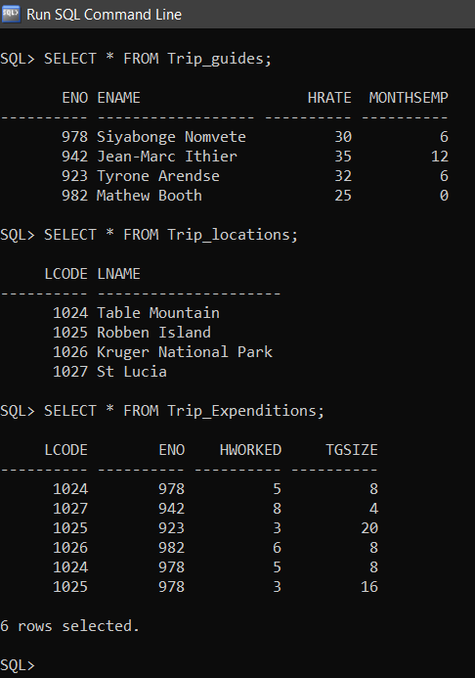

**Answer the following using SQL Joins :**

**i. Display the employee names with their respective tour locations.**

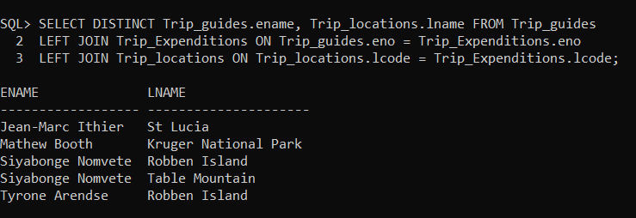

**ii. Display the employee_numbers who had a trip to Table Mountain**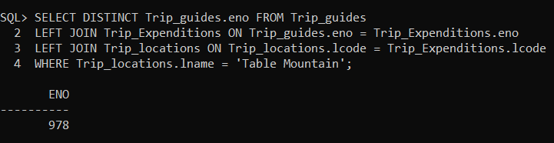

**iii. Display all the employees name regardless of whether they have undertaken a trip or not? (use left outer join)**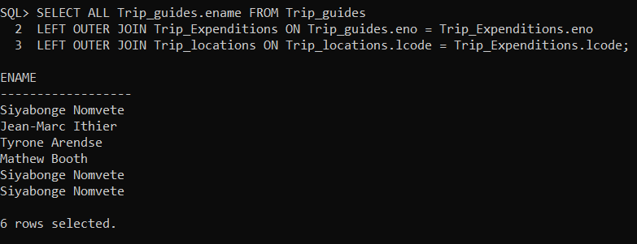

**iv. How do we return the employee numbers, names and locations of all guides, including those who have not yet given a trip**

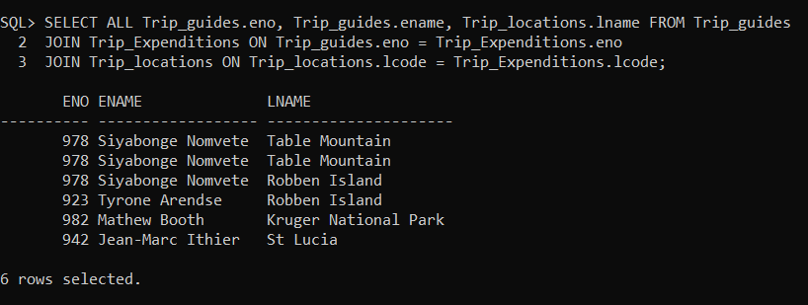

**v. Display all employees who've worked with a trip_group of more than 10 people**

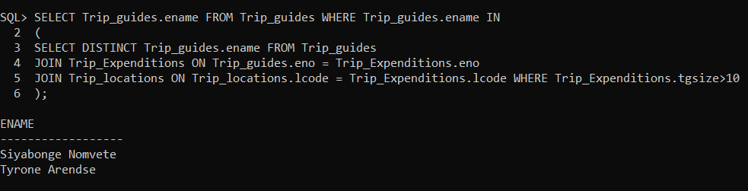

**vi. Find the names of all the employees who have the same hourly rate as Siyabonge Nomvete. (self-join)**

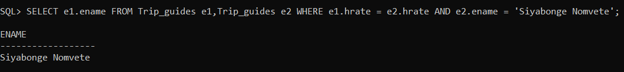

**vii. Display the employee name and employee number who have worked for more than 3 hours.**

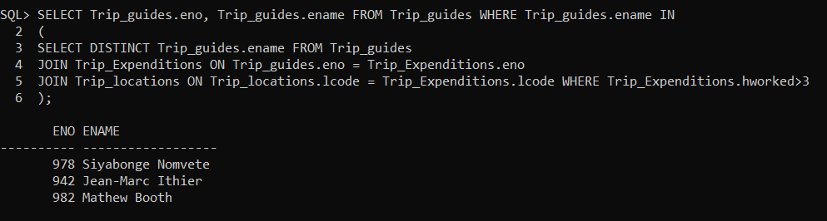

**viii. Display the total information of the trip guides along with their hourly rate in ascending order.**

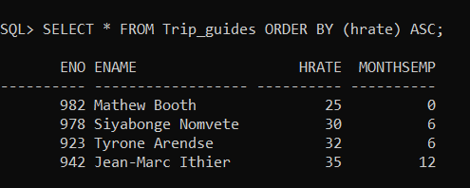

**ix. Display the trip location in which trip_group have visited more than once.**

